?????: ?????: https://www.iasj.net/iasjImages/iasjE.gif 

**EFL Learners' Pragmatic Tolerance**

**of Quantity Maxim Violation**

**Researcher: Maha Khaled Yasseen**

Mosul University

[maha.22ehp34@student.uomosul.edu.iq](mailto:maha.22ehp34@student.uomosul.edu.iq)

**Prof. Dr. Kamal H. Hussein**

Mosul University

[Kamalhaizm67@uomosul.edu.iq](mailto:Kamalhaizm67@uomosul.edu.iq)

Received : 28 /4 /2024 Accepted:1/6/2024 Published:15/9 /2024

**Abstract**

The current study embarks on investigating Iraqi EFL learners' pragmatic tolerance of quantity maxim violations. Additionally, it seeks to shed light on Iraqi EFL learners' pragmatic abilities in deriving pragmatic inferences from utterances that contain violations of quantity maxim. The experimental work in the current study utilized two types of sentence judgment tasks. Binary sentence judgment task for investigating learners' pragmatic tolerance, and ternary judgment task for investigating learners' pragmatic competence. The study included two groups of participants. The first group included 50 participants from 2nd-year students, and the second included 50 from 4th-year students at the Department of English for the academic year 2023-2024;

© THIS IS AN OPEN ACCESS ARTICLE UNDER THE CC BY LICENSE. <http://creativecommons.org/licenses/by/4.0/>

both groups judged underinformative scalar implicature utterances. The results with binary task data indicate that Iraqi EFL learners exhibit tolerance toward quantity maxim violations. However, the ternary judgment task results indicate that Iraqi learners are not competent enough to derive a pragmatic inference. Hence, the current study attempts to provide a comprehensive understanding of EFL learners' pragmatic abilities to derive implied meanings.

**Keywords*:*** Pragmatic Tolerance, Informativeness, Scalar Implicature, Quantity Maxim.

التسامح التداولي لتجاوز نمط الكم لدى متعلمي اللغة الإنكليزية بوصفها لغة اجنبية

|  |  |  |
| --- | --- | --- |
| أ.د. كمال حازم حسين  **جامعة الموصل**  [**Kamalhaizm67@uomosul.edu.iq**](mailto:Kamalhaizm67@uomosul.edu.iq) |  | الباحث: مها خالد ياسين  **جامعة الموصل**  [**maha.22ehp34@student.uomosul.edu.iq**](mailto:maha.22ehp34@student.uomosul.edu.iq) |

ملخص البحث:

تشرع الدراسة الحالية في التحقيق في التسامح التداولي لدى المتعلمين العراقيين للغة الإنكليزية بوصفها لغة اجنبية لتجاوز نمط الكم. بالإضافة إلى ذلك، تسعى إلى تسليط الضوء على قدرات المتعلمين العراقيين في استنتاج الاستدلالات التداولية من العبارات التي تحتوي على تجاوز لنمط الكم. تم استخدام نوعين من مهام تقدير الجمل. مهمة تقدير الجمل الثنائية للتحقيق في التسامح التداولي، ومهمة تقدير الجمل الثلاثية للتحقيق في كفاءة المتعلمين التداولية. شملت الدراسة مجموعتين من المشاركين. تضم المجموعة الأولى 50 مشاركًا من طلبة السنة الثانية، والثانية تضم 50 مشاركًا من طلبة السنة الرابعة؛ حيث قامت كلا المجموعتين بتقدير العبارات التي لا تقدم الكم الكافي للمعلومات. تشير نتائج بيانات مهمة تقدير الجمل الثنائية إلى أن المتعلمين العراقيين يظهرون تسامحًا تجاه تجاوز نمط الكم. ومع ذلك، تشير نتائج مهمة تقدير الجمل الثلاثية إلى أن المتعلمين العراقيين ليسوا كفوئين بما يكفي لاستنتاج استدلال تداولي. تسعى الدراسة الحالية إلى توفير فهم شامل لقدرات المتعلمين في اللغة الإنجليزية بوصفها لغة أجنبية على استنتاج الاستدلالات التداولية.

**الكلمات المفتاحية: التسامح التداولي- الإبلاغيَّة- التلويح السُّلَّمي- نمط الكم**

# **1.Introduction**

Human language is indeed a fascinating and complex system; it consists of many intriguing aspects. One of these is the interlocuter's capability to imply and interpret meanings beyond what is said or meant. This aspect is known as implicature. Grice's (1989) theoretical account of implicature indicates a distinction between what is said and what is intended. Interlocutors derive extra meaning that is not encoded in what is said. This clarifies what implicature theory proposes: the listeners' ability to move from what is said to what is meant, from the level of expressed meaning to implied meaning (Thomas, 1995, p.56). To illustrate this, consider this example:

1. a) John ate some of the chocolate bars.

b) ~ John ate some but not all the bars of chocolate.

The hearer of (1. a) can interpret that John did not eat all of the chocolate bars but some of them, such as in (1. b). Thus, even though the speaker did not mention that he did not eat all the chocolate bars, the hearer can generate the interpretation in (1. b). This kind of inference is, in particular, known as scalar implicature (Horn, 1972). According to Grice (1975,1989), Scalar implicature computation is a complex process involving understanding the speaker's intentions. This process takes into account a wide range of both linguistic and non-linguistic information, including (a) the explicit meaning of what was said, (b) the goal of the statement and assumptions about the speaker's willingness to cooperate, (c) an awareness of the maxim of quantity, which is the understanding that a more informative statement could have been made but was not; and (d) the listener's understanding of the situation, which assumes that the speaker knows the situation.

Grice's Maxim of Quantity (1989), which is highly connected with implicature derivation, has two primary directives: (1) Make your contribution as informative as required for the conversation to proceed. Give only what is necessary. (2) Do not make your contribution more informative than is required. Avoid providing unnecessary details or information that is not requested. Thus, this maxim concerns the amount of information conveyed in an utterance (Cruse, 2015, p. 356). It is also called the maxim of informativeness (Kearns, 2000, p. 258). This maxim encourages interlocutors to provide only sufficient information and not to express more than the required information (Grice, 1989, p. 45). If, for instance, the speaker in (1. a) is cooperative and follows the quantity maxim and truly means (1. b), he uses the weaker term 'some' to be as informative as required; however, if the said (1. a) and the contextual situation show that he "ate all the chocolate bars", he is logically valid and pragmatically infelicitous; therefore, he violates the quantity maxim by being uninformative.

However, implicature comprehension represents a challenging task for second language learners as it happens after decoding linguistic and contextual cues to deduce the implied intention of speakers. Therefore, L2 learners have to bridge the gap between the literal meaning of utterances and their intended meaning (Taguchi, 2013). Interestingly, research on scalar implicature derivation has recently indicated that L2 speakers can derive pragmatic inferences by rejecting underinformative utterances (Slabakova,2010; Snape& Hosoi,2018). Salabkova's (2010) work on Korean L2 learners can be considered a starting point for testing implicature acquisition by EFL learners. In her experiments, participants were asked to judge pragmatically infelicitous "some" utterances that were logically correct, either by "agree" or "disagree" in the English language. According to the results, L2 learners could derive implicature by rejecting underinformative "some" utterances; that is, they provide the pragmatic answer.

Learners' rejection or acceptance of pragmatically infelicitous utterances shows a lot about their pragmatic competence. The previous studies conducted their work utilizing binary judgment tasks, which may need to be more consistent in giving reliable and effective results. Therefore, a more effective experimental method may provide more sufficient and consistent results. As the present paper's primary aim is to investigate EFL learners' pragmatic tolerance of quantity maxim violations and their ability to derive pragmatic inferences from contexts containing such violations, reviewing some literature on this concern is crucial.

**2. Problem of the Study**

Pragmatic inference is a significant challenge in language learning, as learners often struggle to make appropriate inferences from overinformative or underinformative language. This can lead to misinterpretation of language that violates the Gricean maxims, which are the principles of cooperative communication. Learners' responses to such violations reveal their pragmatic tolerance and competence, which are essential for successful communication. However, Iraqi EFL learners face a significant obstacle in acquiring this ability, which can result in miscommunication, offence, social issues, etc.

# **3. Aim of the Study**

The present study aims to investigate Iraqi EFL learners' pragmatic tolerance of quantity maxim violations and their ability to derive pragmatic inferences from contexts containing such violations. Additionally, the present study tries to answer the questions below:

1. To what extent do Iraqi EFL learners show pragmatic tolerance to quantity maxim violations?
2. What is the connection between learners' language proficiency and their pragmatic tolerance?
3. Will Iraqi EFL learners provide pragmatic or logical answers to scalar implicature?
4. Will Iraqi EFL learners show sensitivity toward underinformative utterances in interpreting scalar implicature?

# **4. Hypotheses**

The present study poses the following hypotheses:

1. Iraqi EFL learners exhibit tolerance toward violations of Grice maxims.
2. learners' proficiency is connected to pragmatic tolerance and has crucial effects on it.
3. EFL learners are pragmatically competent and can compute inferences that are not implied within what is said.
4. Iraqi EFL learners are sensitive to underinformative utterances in interpreting scalar implicature.

# **5. Literature Review**

Learners' rejection or acceptance of pragmatically infelicitous utterances shows a lot about their pragmatic competence. The previous studies conducted their work utilizing binary judgment tasks, which may need to be more consistent in giving reliable and effective results. Therefore, a more effective experimental method may provide more sufficient and consistent results. Such an argument is grounded in comparable studies involving L1 children. These studies highlighted methodological flaws in the scalar implicature processing research (Katsos & Bishop, 2011; Katsos & Smith, 2010; Veenstra & Katsos, 2018). In L1 acquisition research, Katsos and Bishop (2010) formulate the Pragmatic Tolerance Hypothesis in light of the results of their experimental work, which indicates that children's acceptance of pragmatically infelicitous statements is due to their pragmatic tolerance that does not indicate they are pragmatically deficient. The concept of this hypothesis was not only restricted to first-language acquisition research, it is also transferred to second-language acquisition research, which can reveal many exciting findings influencing second-language acquisition research.

To the best of the researchers' knowledge, Schulz's (2021) and Feng's (2022) studies of 2L applied the concept of " Pragmatic Tolerance" in their work. Schulz (2021) attempts to provide evidence that L2 learners are not less pragmatically competent than native speakers in deriving scalar implicature. Schulz's (2021) work is limited to scalar implicature derivation by L2 learners. The researcher argues that previous studies in L2 investigated learners' pragmatic competence employing binary judgment tasks, which, he proposes in light of L1 research, is used to investigate learners' pragmatic tolerance and does not show learners' pragmatic competence. Thus, the researcher employs a graded judgment task to measure learners' pragmatic competence and a binary judgment task to investigate their pragmatic tolerance influenced by L1 research. He conducts experiments on German speakers of English and native English speakers. Both groups evaluated underinformative utterances with "some", which violates Grice's maxim of quantity. After comparing the results of the two groups, the findings indicate that German learners are sensitive to violations of informativeness, just as native English speakers are. Regarding pragmatic tolerance, both groups were less tolerant of underinformative utterances.

Feng's (2022) work presents interesting findings by applying the pragmatic tolerance concept, adding additional support for this concept by analysing the data collected from native English speakers and Chinese English speakers. Both groups evaluated underinformative and overinformative utterances, which violate Grice's quantity maxim, on a scale from one to seven through the ternary sentence judgment task exclusively. The findings of the study indicate that pragmatic tolerance is inference-specific. That is, Chinese speakers were more tolerant of overinformative than underinformative.

# **5. Methodology**

This section presents the data collection process in the current study, which is explained in detail in the following sub-sections.

## **5.1 Test Design and Instruments**

This study utilized sentence judgment tasks to investigate pragmatic tolerance and sensitivity toward underinformative utterances among Iraqi EFL learners. Two types of sentence judgment tasks have been used in the study. The first is the binary judgment task inspired by Katsos and Bishop (2010), which was used to investigate the learners' pragmatic tolerance. The second is the ternary judgment tasks used to investigate learners' sensitivity towards over and underinformative utterances and their interpretation of scalar implicature. The study experiment consisted of two parts. The first part involved having participants evaluate underinformative utterances through binary judgment. The second part involved participants evaluating the same utterances they evaluated in the first part through a ternary judgment task.

The tasks in this experiment were designed using Microsoft PowerPoint software. Each task involved creating visual scenarios that included a combination of pictures and utterances related to the pictures of the scenario. A designing computer program created these visual scenarios. They consisted of a short paragraph describing the scenario, followed by fictional characters describing items in boxes before them as described in the scenarios (see Figure 1) (see Appendix 1, also).

|  |  |  |  |
| --- | --- | --- | --- |
| Utterances describing  the pictures |  |  | The Pictures |
| (optimally true)  The students: "Student number one drew a square and a star."  (underinformative)  The students: "Student number two drew a square or a triangle. "    (optimally false)  The students: "Student number three drew a circle and a star. " |  |  |  |
|  |  |  |  |

**Figure 1: A scenario of scalar implicature.**

All the visual scenarios were created in English and printed for participants to use during the experiments. To ensure the test's reliability and ensure that only the participants were involved in the experiment, the use of electronic programs were intentionally not allowed. This procedure was followed to avoid any potential effect on the integrity of the results.

The printed visual scenarios were given to participants during the experiments. This way, participants could read and understand the scenarios without any outside influence. This ensured the results were based solely on the participants' abilities and not on any unknown individual's interference.

**5.2 Participants and Procedure**

The study included two groups of participants, one comprising 50 second-year students aged 19-20 from the University of Mosul College of Education for Humanities, Department of English Language, and the other consisting of 50 fourth-year students aged 22-23 from the same department. All participants volunteered to participate in the study and consented to give their names so they could be tested more than once.

In the conducted study, the participants were divided into two groups: second-year and fourth-year students. Each group spent approximately 15-20 minutes and 10-15 minutes, respectively, on each task. The binary judgment task required the participants to evaluate the utterances as either "satisfied" or "unsatisfied" after reading the scenarios. On the other hand, for the ternary judgment task, participants were asked to rate the same utterances on a scale from 1 to 5. It is worth noting that the purpose of the study was not disclosed to the participants. This approach was adopted to minimise the potential impact of participants' knowledge on their behaviour and, as a result, on the study results.

**6. Results**

The results and analysis of each task in the current study are presented separately in the following sub-sections.

**6.1 Binary Task data**

The binary judgment task is utilized to investigate learners' pragmatic tolerance. However, the answer options in the binary test were ' satisfied'/ 'unsatisfied.' Therefore, performing the statistical analyses required transforming the answer options into numbers. Thus, participants' answers for the optimally true and critical items are scored numerically as illustrated below:

Satisfied / Unsatisfied

1 0

Meanwhile, participants' answers, inspired by Pipijn and Schaeken (2012), for the optimally false items are scored reversely as indicated below:

Satisfied / Unsatisfied

0 1

This reversal of the data input in the statistical program allows a more comprehensive data analysis process. It prevents any miscomprehension between the results of control items and the results of critical items, as participants are normally expected to provide high ratings of the true optimal items and low ratings for the optimally false ones. Thus, participants' mean answer scores for these control items were expected to approximate '1.' However, results and analysis of the binary task data of scalar implicature items are discussed in the paragraphs below.

As mentioned earlier, the binary judgment task targets learners' pragmatic tolerance. Therefore, participants are considered pragmatically tolerant when their mean answer scores, in this task, approximate "1"; conversely, they are considered pragmatically intolerant when their mean answer scores approximate "0". Starting with the optimal items of the study, participants in both groups perform as expected by accepting the optimally true and rejecting the optimally false items. Approximately 85% of participants accept the optimally true items, and approximately 80% reject the optimally false items. Concerning the critical items, the second-year participants show a higher level of pragmatic tolerance than the fourth-year participants since their mean answer score indicates that they accept underinformative items most of the time (see Table 1& Fig 2).

**Table 1: Both groups' mean answer score and standard error mean of underinformative scalar items.**

|  |  |  |
| --- | --- | --- |
| S.E Mean | Mean | Groups |
| 0.037 | 0.58 | second-year |
| 0.043 | 0.42 | fourth-year |

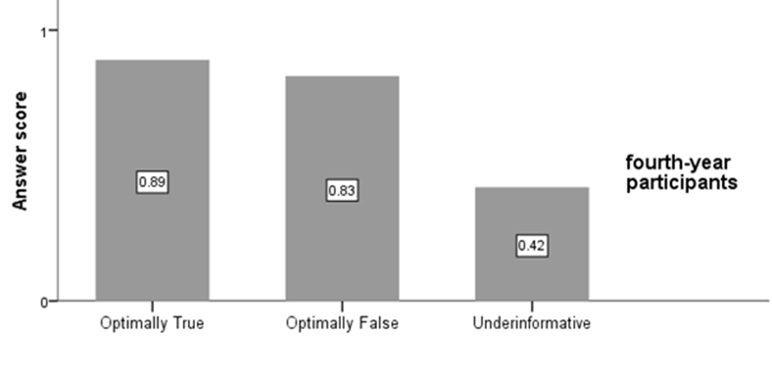

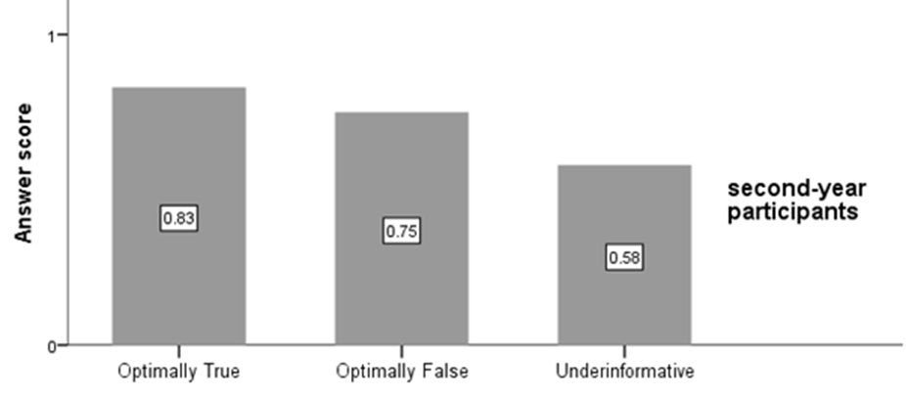

**Figure 2: Mean answer score of all participants in both groups per item in the binary task.**

To investigate the difference in pragmatic tolerance between second and fourth-year participants, a between-group test of mean answer score difference has been conducted. This test assists in revealing whether there is a statistically significant difference in the mean answer score behaviour for underinformative scalar items between the second-year and fourth-year groups in the binary task. Due to the non-normal distribution of the data as the Shapiro-Wilk tests of normality results indicate (second-year participants: W (50) = 1.910, p˂ 0.05; fourth-year participants: W (50) = 1.907, p˂ .05) and inspired by Katsos and Bishop (2011), a non-parametric Mann-Whitney U-test has been conducted. The test results reveal a statistically significant difference between the groups' mean answer scores of underinformative scalar items. Thus, the second-year participants have a higher level of pragmatic tolerance than the fourth-year participants (U= 865.0, p < .05).

Further, following Katsos and Bishop (2011), an analysis has been made to examine the consistency of participants' pragmatic tolerance toward underinformative scalar items. Both participants groups are classified into three sub-groups: those who show consistent pragmatic intolerance (rejecting 3-4 out of four underinformative statements), those who show inconsistent pragmatic tolerance (rejecting 2-3 out of four statements), and those who show consistent pragmatic tolerance (rejecting 0-1 out of four statements) as illustrated in Table 2 below. Such analysis would make the picture clearer concerning both groups' pragmatic tolerance.

**Table 2: Three sub-groups of participants regarding their pragmatic tolerance/intolerance consistency.**

|  |  |  |  |
| --- | --- | --- | --- |
|  |  | The number of participants who show |  |
| Groups | Consistent pragmatic intolerance | Inconsistent pragmatic tolerance | Consistent, pragmatic tolerance |
| Second-year | 11 | 14 | 25 |
| Fourth-year | 26 | 10 | 14 |

In their answers, 50% of second-year participants show consistent pragmatic tolerance of underinformative scalar statements (i.e., accepting underinformative statements). On the other hand, 51% of fourth-year participants show consistent pragmatic intolerance in their answers (i.e., rejecting underinformative scalar statements). According to the results of the binary task, those who show inconsistency of pragmatic tolerance in their answers seem to lack essential aspects of pragmatic competence to comprehend the statements and to perform the task properly, in addition to those who are pragmatically tolerant most of the time. Furthermore, they do not derive the quantity implicature or detect the violation of quantity maxim. This is what most of the literature on implicature acquisition in second language research depicts. Therefore, language proficiency stems here since high consistency in pragmatic intolerance can be clearly observed among fourth-year participants. This provides evidence that learners' proficiency intervened in their pragmatic tolerance.

However, the pragmatic tolerance hypothesis proposes that participants' acceptance of underinformative items is due to their tolerance of pragmatically infelicitous items rather than their lack of pragmatic competence. To test such an assumption, participants are given a ternary task.

**5.2 Ternary Task Data**

The ternary judgment task investigates learners' pragmatic competence, sensitivity toward underinformative utterances, and ability to interpret scalar implicature. However, the answer options in the ternary task are "1, 2, 3, 4,5." Each number stands for:

1="Unsatisfied"

2= "Somewhat unsatisfied"

3= "Neither"

4="Somewhat satisfied."

5="Satisfied"

It is essential to mention that participants were informed during the experiment sessions that the lowest rating is "1" and the highest is"5" to ensure that they comprehend the process of answering and to have them produce their rating effectively. However, this data input in the statistical analyzing program is for the optimally true and underinformative items. The data input for the optimally false items is reversed, as indicated below:

5="Unsatisfied"

4= "Somewhat unsatisfied."

3= "Neither"

2="Somewhat satisfied"

1="Satisfied"

Participants' mean answer scores for the optimally true and the optimally false scalar items are expected to approximate "5". However, for the underinformative scalar items, participants' mean scores approximating "5" would only make them seem to comprehend the logical meaning of the utterances. That is, they make semantic interpretation of scalar implicature rather than pragmatic interpretation. On the other hand, with mean answer scores approximating "1", participants are considered to be able to interpret the pragmatic meaning of scalar implicature items in addition to their semantic one. However, the results and analysis of the ternary task are introduced in the following paragraphs.

Essentially, participants are considered to be sensitive toward underinformative scalar utterances and derive their pragmatic meaning by giving them intermediate evaluations (i.e., "somewhat satisfied /neutral / somewhat unsatisfied") or rejecting them (i.e., unsatisfied). This can be examined statistically by analyzing participants' answers, whether they give lower ratings to underinformative scalar items than control items or vice versa (i.e., optimally true and optimally false items). Participants are generally expected to perform at the ceiling (i.e., their mean answer scores approximate '5') in all control items. Visually, according to the results presented in Table 3 below, both groups' mean answer scores approximate '5' in control items. In contrast, both groups' mean answer scores for underinformative items are lower than the control items. Besides, the second-year group shows lower sensitivity than the fourth-year group. This can be investigated further by conducting the following statistical tests.

**Table 3: Both groups' mean answer score and standard error mean of underinformative scalar items.**

|  |  |  |
| --- | --- | --- |
| Groups | Mean | S.E mean |
| Second-year | 3.25 | 0.132 |
| Fourth-year | 2.84 | 0.103 |

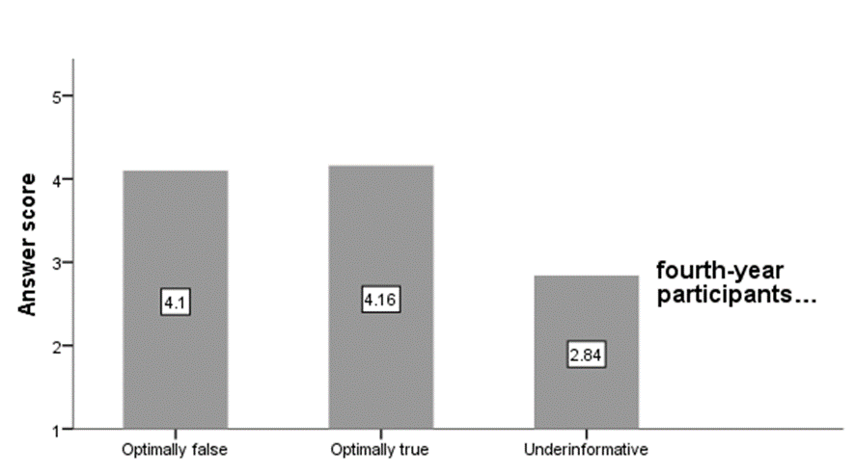

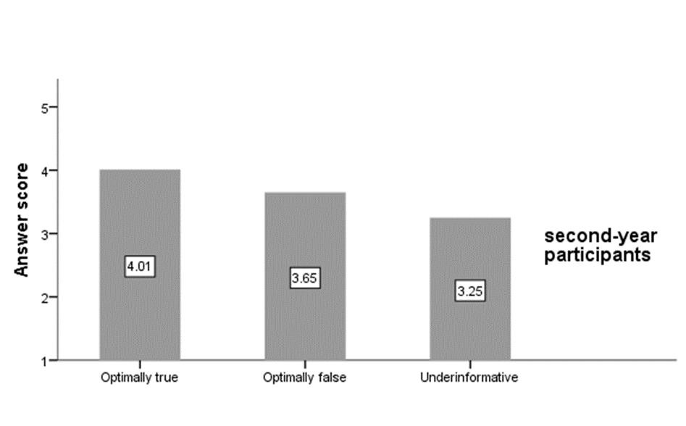

**Figure 3: Mean answer score for both groups in the ternary task.**

Significantly, the observation concerning groups' sensitivity toward underinformative has been examined statistically to understand both groups' behaviour toward underinformative utterances and to show the difference between the two groups. This is done by conducting within-group tests of mean answer score difference for each group. Depending on the results of Shapiro-Wilk tests of normality, which are all p˃0.05 indicating a non-normal distribution, non-parametric tests are conducted. Further, the visual examination of the data distribution supports non-parametric tests. Thus, the Friedman test has been conducted for each group. According to the results, in both groups, there is evidence for a statistically significant difference in the mean answer scores for utterance type (second-year group: Friedman χ2(2) = 20.24, p<0.05; fourth-year group: Friedman χ2(2) = 40.35, p<0.05). To investigate this further, utterances are put in pairs to show between which type of utterances the difference is; therefore, post-hoc Wilcoxon signed-rank tests are run to gain the information needed for further understanding.

The results of post-hoc Wilcoxon signed-rank tests indicate that in the second-year group there are significant differences between all the pairs. That is, there are significant differences in the mean answer scores between "the optimally true and optimally false statements" (Z= -2.152, p<0.05), between "the optimally true and underinformative statements" (Z=-4.295, p<0.05), and between '"the underinformative and optimally false statements" (Z= -2.014, p<0.05). However, the differences between "the underinformative statements and the optimal statements" are expected, but surprisingly, the results from " the optimally true and optimally false statements" are unexpected. Although second-year group participants exhibit sensitivity toward underinformative utterances as they rated them lower than the control items, the difference they show in their answers between optimally true and optimally false items questions their linguistic abilities. Thus, proficiency level presents itself here as one of the possible factors affecting participants' linguistic performance.

On the other hand, in the fourth-year group, there are no significant differences in the mean answer scores between " the optimally true and optimally false statements." However, there are significant differences in the mean answer scores between the optimally true and underinformative statements" (Z=-5.395, p<0.05) and between " the optimally false and underinformative statements "(Z=-5.205, p<0.05). All in all, since both groups evaluate the underinformative statements lower than the optimal statements, it can be indicated that both groups show sensitivity to underinformative statements. However, the fourth-year group seems to interpret pragmatic meaning, while the second-year group seems to interpret only logical meaning. This can be observed in the mean answer score of both groups: the second-year group's mean answer score approximates 5, while the fourth-year group's mean answer score approximates 1. It has been evidenced that language proficiency has a considerable effect on pragmatic competence. Hence, groups' differences in their pragmatic competence are attributed to differences in their language proficiency (Taguchi,2006).

Additionally, between-groups comparisons, following Katsos and Bishop (2011), using Mann–Whitney U tests, depending on the non-normal distribution of the data (Larson-Hall,2016), have been conducted to investigate if there is a statistically significant difference in the mean answer scores between the second-year and fourth-year participants in all conditions (i.e., optimally true, optimally false, and underinformative items). The results reveal that for optimally true items there is no statistically significant difference (U=1244.0, p˃0.05) between both groups, but for both underinformative and optimally false items, there is a considerable difference (underinformative items: U=901.5, p˂0.05; optimally false items: U=888.5, p˂0.05). This indicates that both groups do not differ in their responses to optimally true items but in their reactions to optimally false and underinformative items. It can be confirmed once again that the difference detected in groups' answers to underinformative and false control items can be mostly attributed to their levels of proficiency and their cognitive abilities.

Furthermore, participants are classified into three categories according to their sensitivity toward underinformative. Namely, consistent sensitivity to underinformative (i.e., when they give 'unsatisfied,' 'somewhat satisfied,' 'neither,' or 'somewhat satisfied' answers), inconsistent sensitivity to underinformative (i.e., when they give 'unsatisfied,' 'somewhat satisfied,' 'neither,' 'somewhat satisfied,' or 'satisfied' answers), and no sensitivity to underinformative (i.e. when they only give 'somewhat satisfied' or 'satisfied' answers).

**Table 4: Individual participants' performance of consistent sensitivity to underinformative scalar items in the ternary task of both groups**

|  |  |  |  |
| --- | --- | --- | --- |
|  | The number of participants who show |  |  |
| Groups | Consistent sensitivity to underinformativeness | Inconsistent  sensitivity to underinformativeness | No sensitivity to underinformativeness |
| Second-year | 12 | 28 | 10 |
| Fourth-year | 30 | 18 | 2 |

According to Table 4 above, 57% of second-year participants show inconsistent sensitivity to underinformativeness, while 60% of fourth-year participants show consistent sensitivity to underinformativeness. Thus, the second-year and fourth-year groups are classified into one being pragmatically oblivious and one being pragmatically competent, respectively.

All in all, in the literature on second language acquisition, learners' proficiency represents a crucial part of their pragmatic competence, although it does not promise complete pragmatic competence (Garcia, 2004; Hoffman-Hicks, 1999; Hamidi & Khodareza, 2014). This can be detected here since the second-year participants, according to the results, are classified as pragmatically oblivious. Therefore, their tolerance of pragmatically infelicitous emanates from their weak pragmatic competence. An inverse relationship can be observed here between pragmatic tolerance and language proficiency. That is, the lower language proficiency the higher pragmatic tolerance, and vice versa.

**7.** **Conclusion**

The current study aims to investigate Iraqi EFL learners' pragmatic tolerance of quality maxim violations. Essentially, it has been found that Iraqi EFL learners exhibit tolerance toward Grice's maxims violations. This implication is attributed to their answer behavior toward infelicitous pragmatic utterances. Not to be considered a surprise, pragmatic tolerance is widespread among participants with less language proficiency, while the matter is not the same for pragmatic competence. This indication comes from the difference in answer behaviour between the two groups tested in the current study. The fourth-year participants were less pragmatically tolerant and more pragmatically competent. Conversely, the second-year participants were more pragmatically tolerant and less competent. In this respect, language proficiency has a crucial impact on Pragmatic Tolerance. In light of the current study findings, Iraqi EFL learners are somehow pragmatically incompetent. Their weak performance in the current study demonstrates how pragmatic competence represents a challenge for Iraqi EFL learners.

**References**

1.Cruse, D. A. (2015). Meaning in language: An introduction to semantics and pragmatics. Oxford University Press.

2.Davies, C., & Katsos, N. (2010). Over-informative children: Production/comprehension asymmetry or tolerance to pragmatic violations? Lingua, 120, 1956–1972

3.Feng, S. (2022). L2 tolerance of pragmatic violations of informativeness. Linguistic Approaches to Bilingualism.

4.Garcia, P. (2004). Pragmatic Comprehension of High- and Low-Level Language Learners.

5.Grice, H. P. (1975) Logic and Conversation. In P. Cole & H. Morgan (Eds.). Syntax and Semantics. Vol. 3: Speech Acts (pp. 41-58). New York: Academic Press.

6.Grice, P. (1989). Studies in the way of words. Cambridge, MA: Harvard University Press.

7.Hamidi, B., & Khodareza, M. (2014). The Relationship between Iranian EFL Learners’ Language Proficiency and Pragmatic Competence. ELT Voices.

8.Hoffman-Hicks, S. (1999). The longitudinal development of French foreign language pragmatic competence and evidence from study abroad participants. Indiana University, Bloomington.

9.Horn, L. R. (1972). On the semantic properties of logical operators in English. Doctoral dissertation. Distributed by the Indiana University Linguistics Club.

10.Katsos, N., & Bishop, D. V. M. (2011). Pragmatic tolerance: Implications for the acquisition of informativeness and implicature. Cognition, 120(1), 67–81

11.Kearns, K. (2000). Semantics. London: Macmillan Press Ltd.

12.Larson-Hall, J. (2015). A guide to doing statistics in second language research using SPSS and R. Routledge.

13.Pipijn, K. & Schaeken, W. (2012). Children and Pragmatic Implicatures: A Test of the Pragmatic Tolerance Hypothesis with Different Tasks. Proceedings of the Annual Meeting of the Cognitive Science Society 34, 2186-2191.

14.Schulz, J. M. (2021). Pragmatic competence and pragmatic tolerance in foreign language acquisition – revisiting the case of scalar implicatures [Master's thesis]. University of Oxford.

15.Slabakova, R. (2010). Scalar implicatures in second language acquisition. Lingua, 120, 2444–2462.

16.Snape, N., & Hosoi, H. (2018). Acquisition of scalar implicatures: Evidence from adult Japanese L2 learners of English. Linguistic Approaches to Bilingualism, 8, 163–92.

17.Taguchi, N. (2006). Analysis of appropriateness in a speech act of request in L2 English. Pragmatics, 16(4) 513–533.

18.Taguchi, N. (2013). Implicature. In Robinson, P. (Ed.). (2013). The Routledge Encyclopaedia of Second Language Acquisition. New York, NY: Routledge.

19.Thomas, J. (1995). Meaning in Interaction: An Introduction to Pragmatics. London: Routledge.

20.Veenstra, A., & Katsos, N. (2018). Assessing the comprehension of pragmatic language: Sentence judgment tasks. In K. P. S. Andreas H. Jucker & W. Bublitz (Eds.), Methods in pragmatics (pp. 257–279). De Gruyter Mouton. DOI: <https://doi.org/10.1515/9783110424928-010>.

**Appendix (1)**



